Lab Assignment #3
Cryptography

Steffen L. Norgren <ironix@trollop.org>
A00683006

COMP 7615 • BCIT • September 28, 2009

Table of Contents

Purpose 3
Procedures 3
Texts Used 3
Step #1 - Open Texts 3
Step #2 - Produce Histograms of Unencrypted Texts 4
Step #3 – Encrypt Texts 4
Step #4 – Produce Histograms of Encrypted Texts 5
Histogram for Unencrypted Text #1 6
Histogram for Unencrypted Text #2 6
Histogram for Unencrypted Text #3 7
Histogram for Encrypted Text #1 7
Histogram for Encrypted Text #2 8
Histogram for Encrypted Text #3 8
Discussion 9
Conclusion 9

Purpose
To compare and analyse the character distribution histograms of texts encrypted using the Vignère cipher.

Procedures

Texts Used
- Text #1 – Astounding Stories of Super-Science, February 1930:
http://www.gutenberg.org/ebooks/28617
- Text #2 – Astounding Stories of Super-Science, March 1930:
http://www.gutenberg.org/ebooks/29607
- Text #3 – Astounding Stories of Super-Science, April 1930:
http://www.gutenberg.org/ebooks/29390

Step #1 - Open Texts
Open the reference texts.
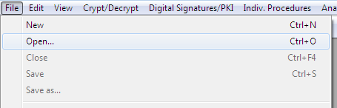

Step #2 - Produce Histograms of Unencrypted Texts
For all three texts, produce a histogram of the character frequency.
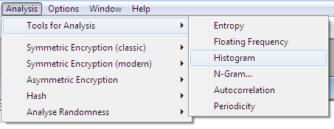

Step #3 – Encrypt Texts
Encrypt all three texts using the Vigenere cipher.
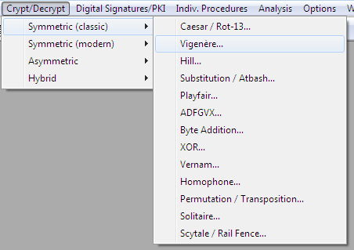
Use any encryption key you wish.
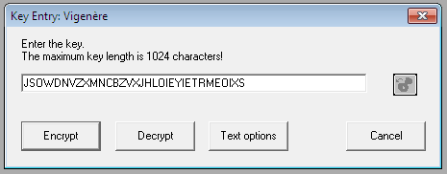

Step #4 – Produce Histograms of Encrypted Texts
For all three encrypted texts, produce a histogram of the character frequency.

Histogram for Unencrypted Text #1
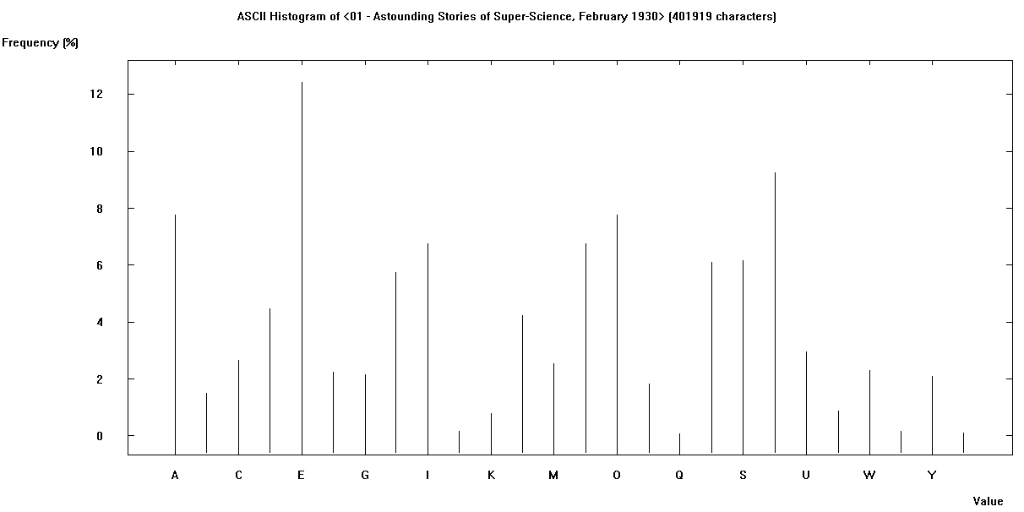

Histogram for Unencrypted Text #2
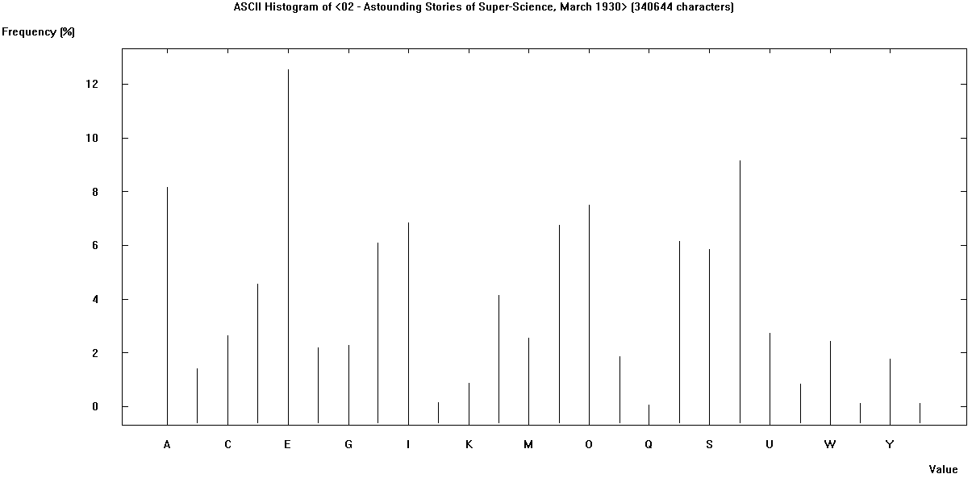

Histogram for Unencrypted Text #3

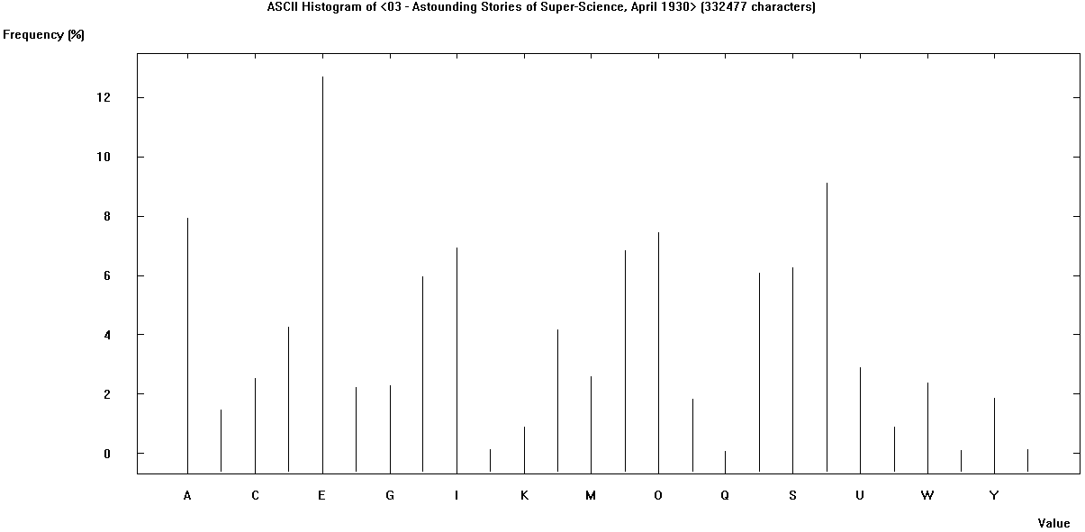

Histogram for Encrypted Text #1
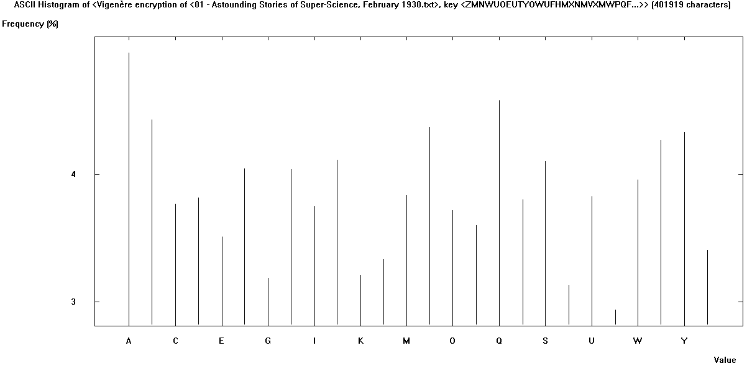

Histogram for Encrypted Text #2
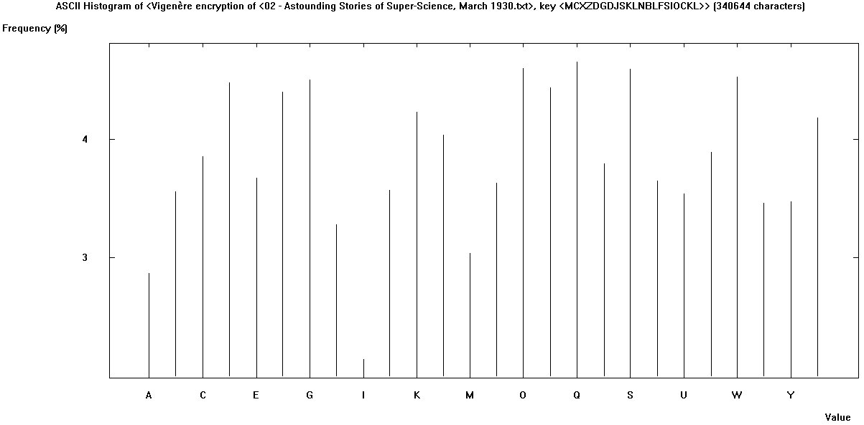

Histogram for Encrypted Text #3
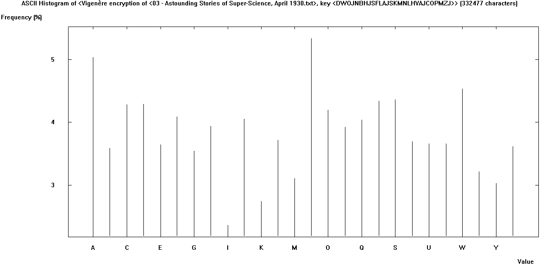

Discussion
In encrypting the reference texts using the Vignère cipher, I entered in a fairly long encryption key. Additionally, I used a different encryption key for each of the reference texts. This is why the histograms for each of the encrypted texts differ as much as they do.
Looking at this histograms for each of the encrypted texts and comparing them with the original unencrypted text, we can see that it is not easy to discern the encryption key used in each case.

Conclusion
Upon first glance, a Vigenère cipher encrypted text looks difficult to decrypt. However, if one knew the length of the key, or guessed the key length, then all one would need to do would be to subtract the cipher text from itself, offset by the key length, will produce the cipher key used to encrypt the text to begin with.

